**Model Diven App User Guide**

* Login to Dataverse using the user using the user account is configured already
* By default All the Safety Critical Observations are displayed when the User logged in , they can navigate to active Inactive Observation by changing the view
* User can Open the Observation and Modify if required

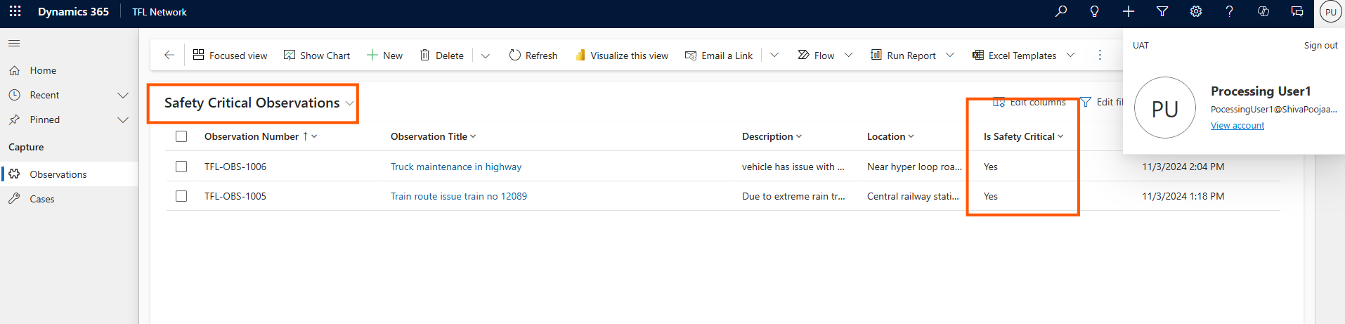

* In the Form User can see Created By ,Status , post creation observation will be assigned to **Observation Processing team**
* If Observation Need to be Escalated then user can use the **Convert to case** button on the Ribbon
* When Observation is converted into case the Observation will be set to Completed status marking as inactive.
* An mail will triggered to the User who created the Observation with Details of it. 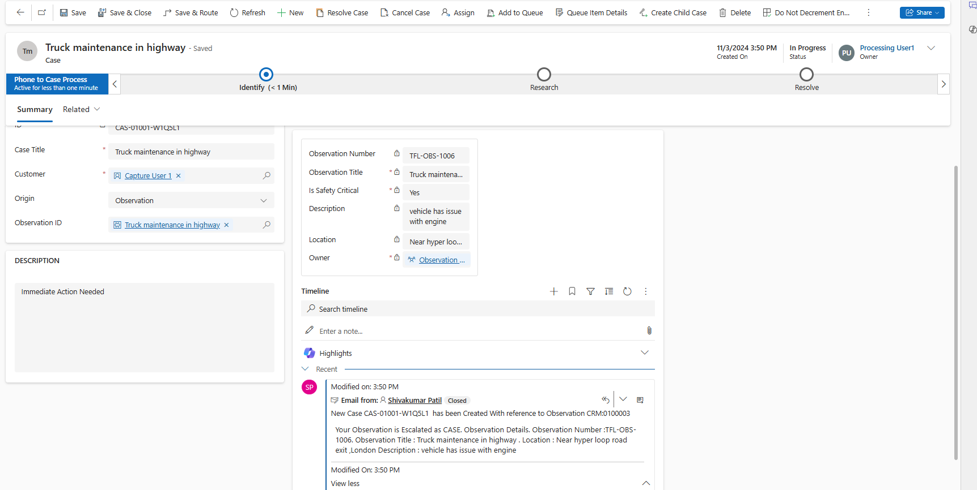
* User can See the Captured Image in the Photos Grid , Each image is stored as record in Photos Section

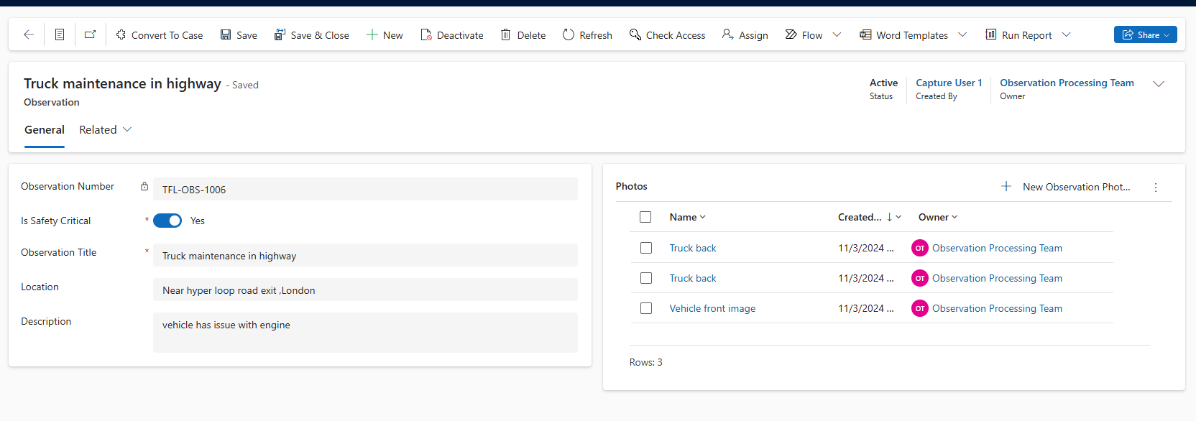

* User can open and verify Image.

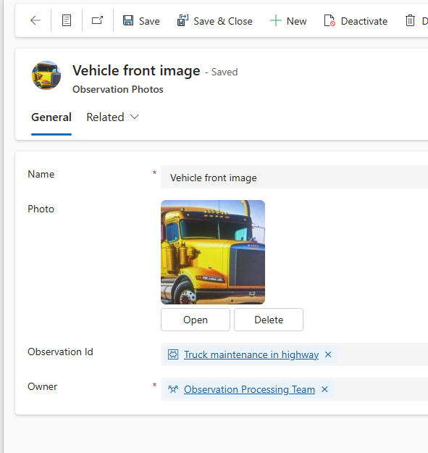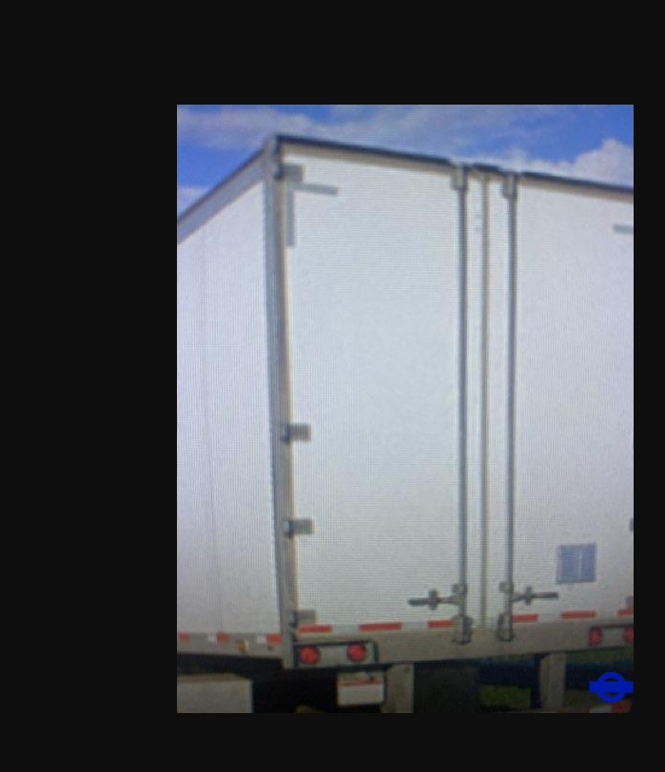

* If Observation Need to be Escalated then user can **Convert to case** Option on the Ribbon